Ping Zhang, Gisela M. von Dran. (2000). Satisfiers and Dissatisfies: A Two-Factor Model for

Website Design and Evaluation. *Journal Of The American Society For Information Science.* [online] 51(14), p. 1253-1268. Available at: [Accessed on 31 September 2016].

(Ping Zhang and Gisela, 2000)

Pg 1253

2types of website design factors: hygiene and motivator.

Hygiene: those whose presence make a website functional and serviceable,, and whose absence causes user dissatisfaction.

Motivator factors: those that add value to the website by contributing to user satisfaction.

Info:with the swift development and increasing use of the www as both an information-seeking and an electronic commerce tool, web user interface studies grow in significance*. Poor interface functionality is one potential cause for web usability meltdown.*

User satisfaction with a website or users liking a website is one of the many goals web designers want to achieve. Satisfied users may spend a longer time and revisit the website and may recommend it to others.

Pg 1254

The type or purpose of a website usually implies the kind of tasks users can do with it, although it’s not necessarily true.

Web design may spend considerable time, attention, and other resources on design factors without a conscious understanding of the factors impact.

Pg1257

Website design factors need to be clearly defined. Specific features and categories that refer to a group of similar features.

Pg1259

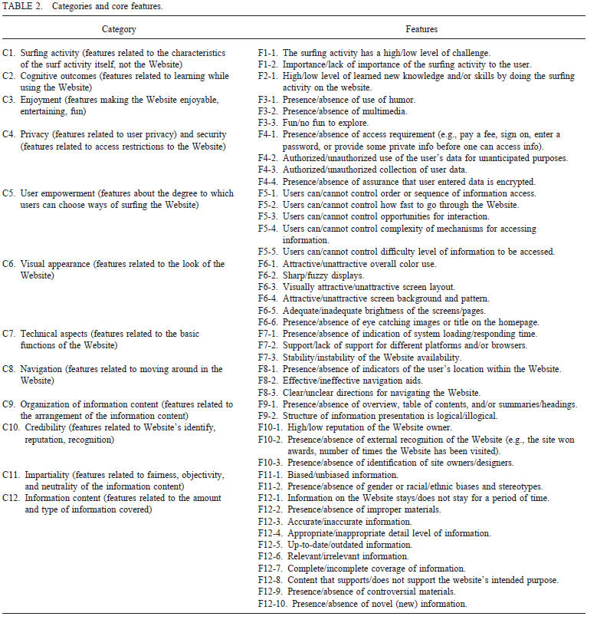

Pg1262

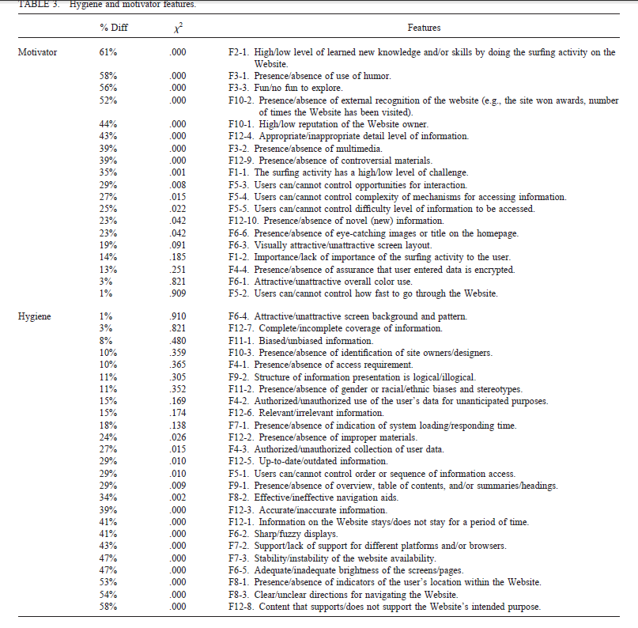

Pg1265

Enjoyment, cognitive outcome, credibility.

Organization of information and information content